**SPRINT – 4**

**Signs with Smart Connectivity for Better Road Safety**

**TEAM ID- PNT2022TMID08042**

TO CREATE A WEB UI (INTERACT WITH USER):

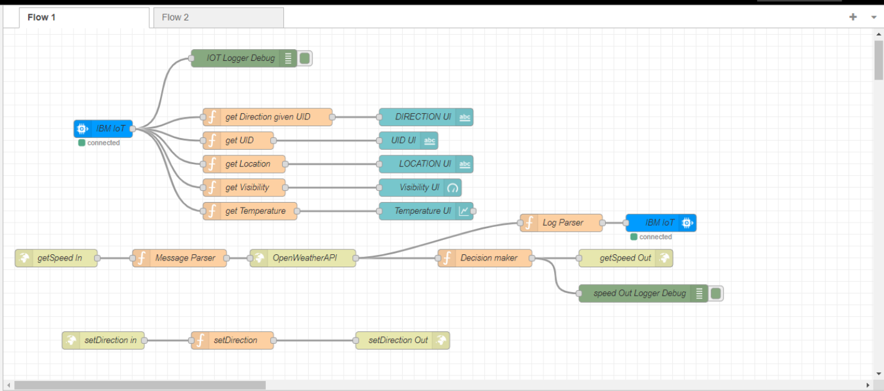

CREATE A NODE RED SERVICE:

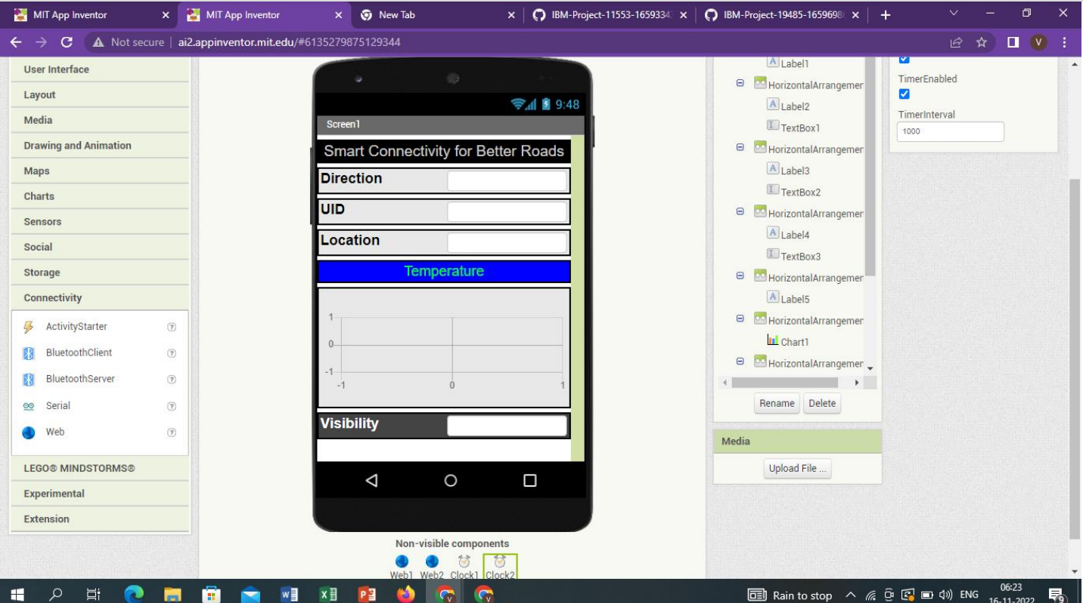

CREATE A DASHBOARD UNIT FOR THE WEB APPLICATION

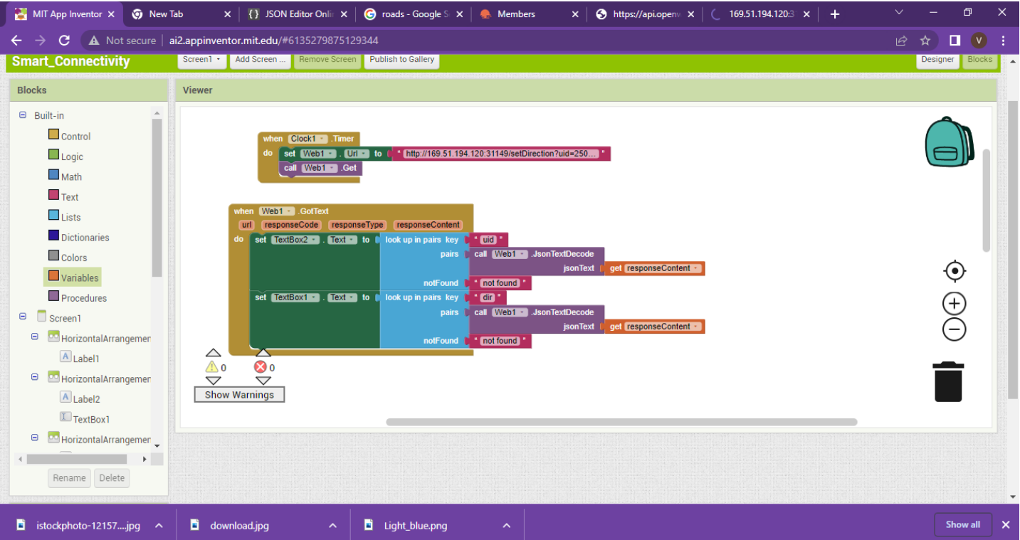

CREATE A DASHBOARD UNIT FOR THE WEB APPLICATION

